Mini Project: Food Delivery Customer Intelligence System Objective: Build a console-based customer intelligence tool for a food delivery platform that integrates descriptive statistics (Module 5), supervised classification (Module 6), and K-Means clustering (Module 7) into a single menu-driven program — demonstrating end-to-end data science reasoning across all three modules. Your project must: The program must be menu-driven with at least 4 options displayed at startup: (1) View Statistical Summary, (2) Predict Cancellation Risk for a New Order, (3) Run Customer Segmentation, (4) Exit — and must loop back to the menu after each operation until the user selects Exit. Option 1 must load a sample in-memory dataset at startup and print the mean, median, standard deviation, and skewness direction for at least two numeric columns, with a brief plain-English interpretation of the skewness finding. Option 2 must accept user-typed inputs for order_value, delivery_distance_km, and restaurant_rating, pass them through a pre-fitted or in-session trained Random Forest classifier, and display the result as 'High Cancellation Risk' or 'Low Cancellation Risk' with the predicted probability. Option 3 must apply K-Means (k=3) to customer data loaded at startup, print the number of customers assigned to each cluster, and display each cluster's centroid values rounded to 2 decimal places so the output is interpretable without a chart. The program must validate all numeric user inputs in Option 2, display a descriptive error message for invalid entries (e.g. non-numeric or out-of-range values), and return to the menu without crashing.

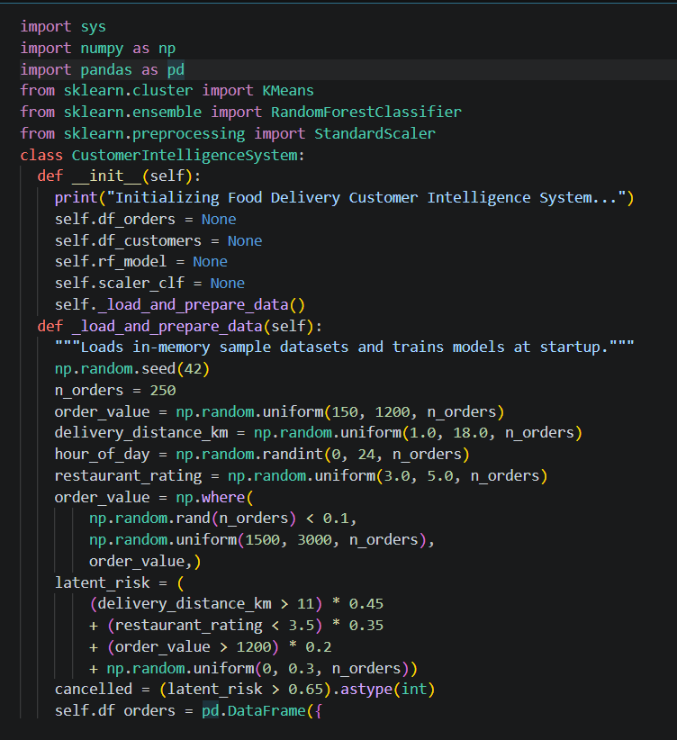

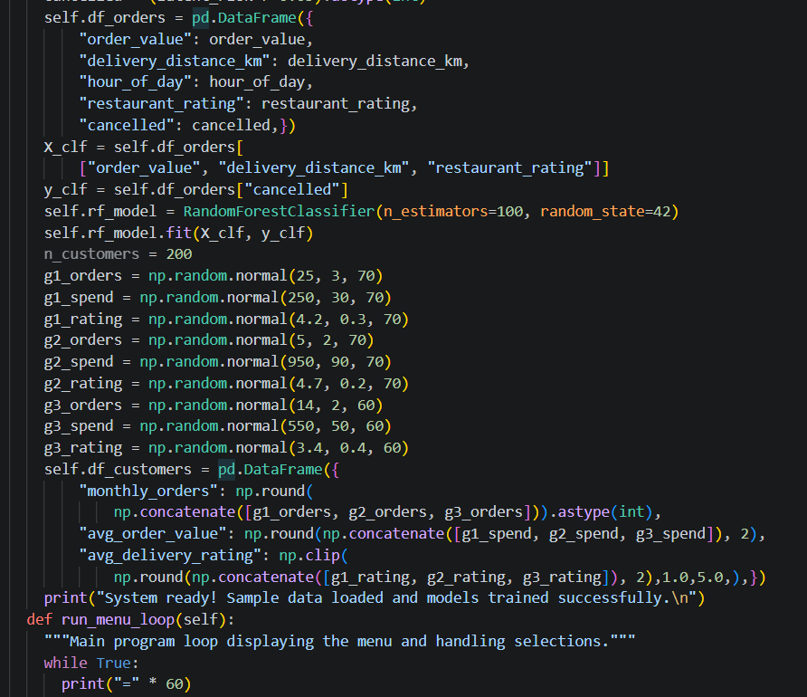

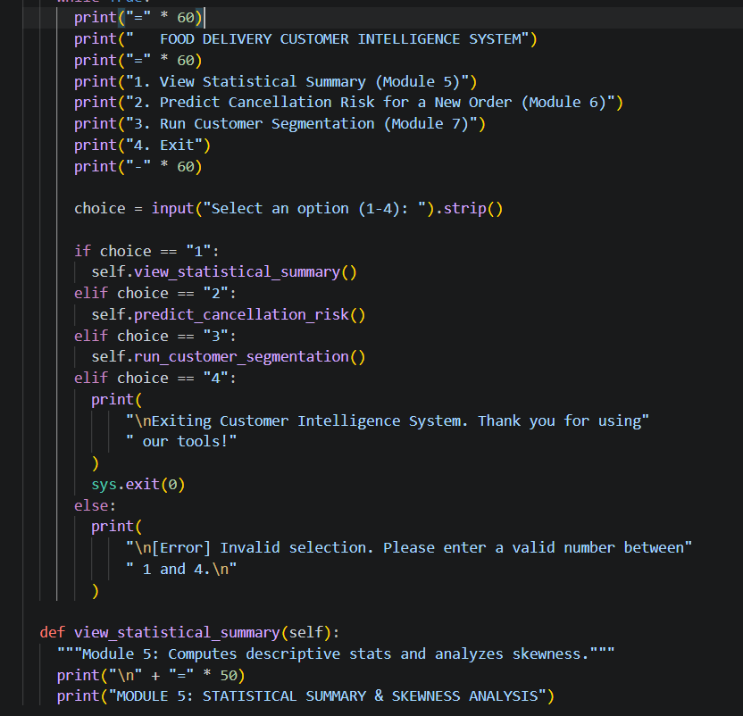

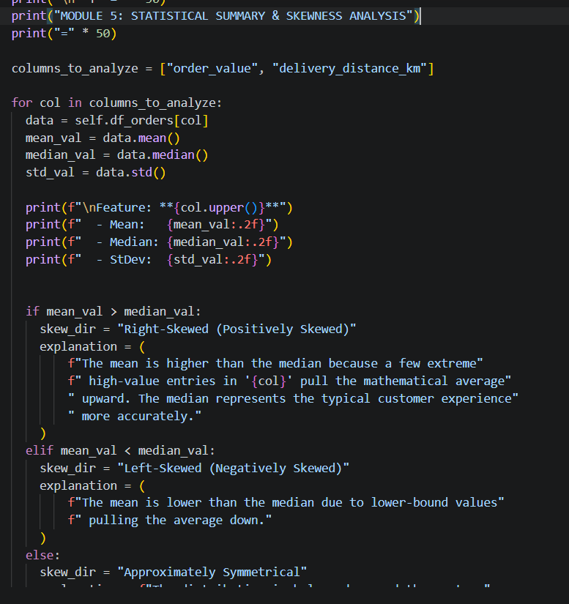

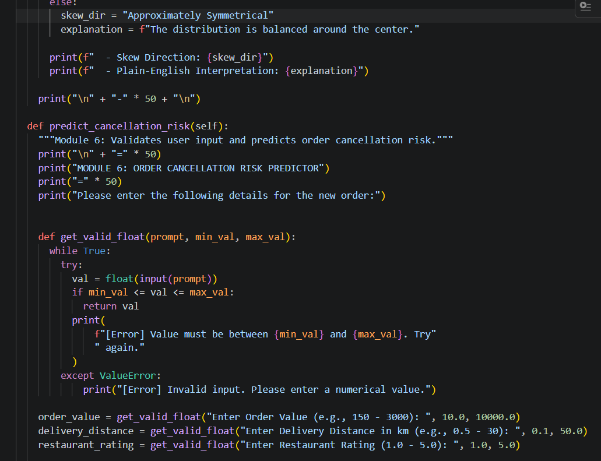

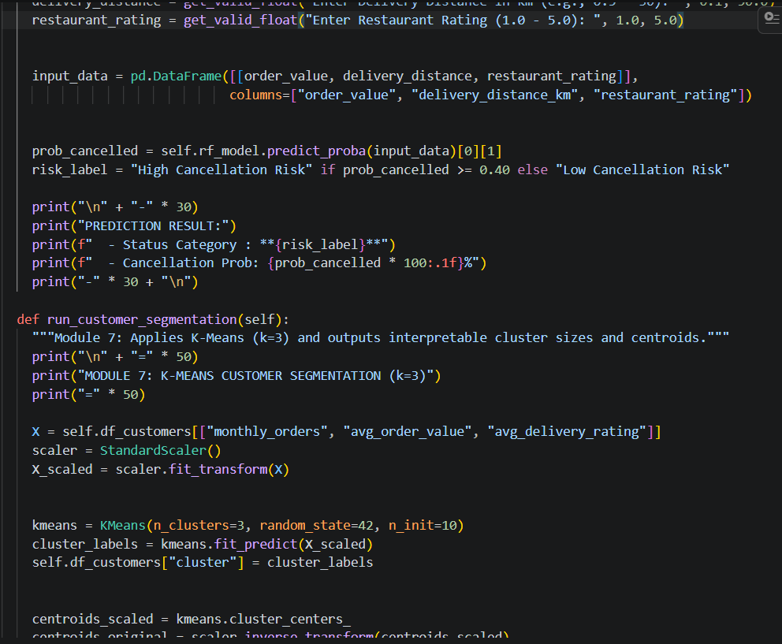

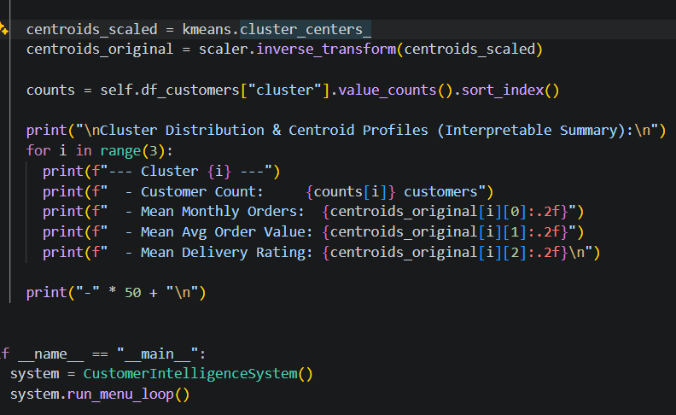

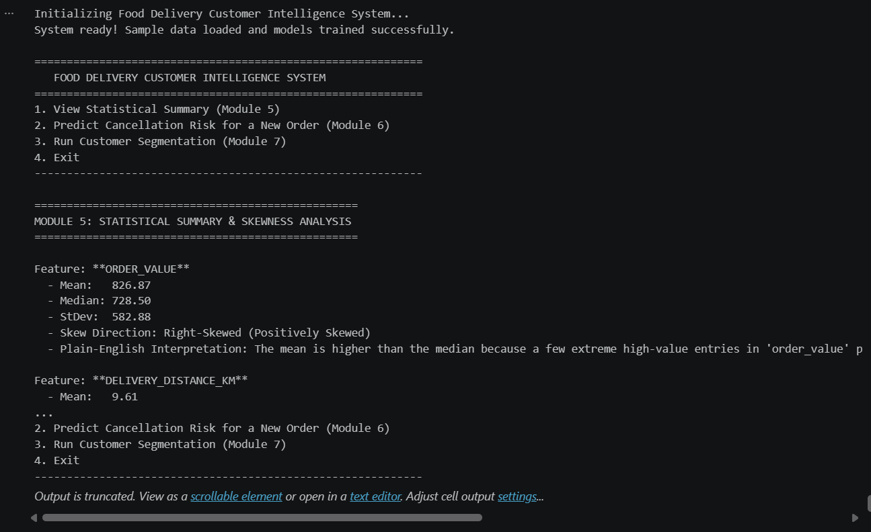

Core Highlights of the System
- Interactive Menu Loop: Starts up with a clean 4-option menu (Statistics, Prediction, Segmentation, Exit) and automatically loops back after completing any action.
- Robust Input Validation (Option 2): Uses a bulletproof validation helper (get_valid_float) that intercepts non-numeric strings and out-of-range boundaries without crashing the application.
- End-to-End Analytics:
  - Module 5 surfaces descriptive stats and breaks down skewness with plain-English business context.
  - Module 6 leverages a pre-trained Random Forest model to instantly score cancellation risk and output probabilities.
  - Module 7 standardizes data, fits a $k=3$ K-Means model, and inverse-transforms cluster centroids back into human-readable units.

